

**Java Institute for Advanced Technology**

**UNIT NAME** – SOFTWARE APPLICATION DEVELOPMENT

**UNIT ID** - H7E1



**NAME – Tuwan Munaff Adahan**

**SCN NO - 207981850**

**NIC – 199627703028**

**BRANCH – Colombo Branch**



**LIST OF ACRONYMS**

**DBMS** Data Base Management System

**DB** Database

**SQL** Structured Query Language

**IDE** Integrated Development Environment

**OOP** Object Oriented Programming

**UML** Unified Modeling Language

**ER** Entity Relationship

**PC** Personal Computer

**PDF** Portable Document Forma

**HDD** Hard Disk Drive

**RAM** Random Access Memory

**GRN** Goods Received Note

**GUI** Graphical User Interface

**1 INTRODUCTION**

Nowadays management scheme is a mostly necessary thing for a company or big or small business even. Cannot keep a hope of an existence instead of management system. To do the managerial tasks properly and effectively one needs highly efficient tools

In this Hardware Management System use to maintain, their sales detail goods received notes in files and folders. They are used to keep a record of products sold, product categories, brands, models, customers, suppliers, etc. and easily find them again in case of need. It called “ZHardware”. This leads to an error-free, secure, reliable and fast management system. It helps staff to focus on their other activities without focusing on record keeping. Therefore, this software will help in better utilization of resources.

**1.2 Problem Statement**

A system is needed to computerize all the records as the store still works manually with documented information. The aim of this project is to facilitate the easy sale of all types of merchandise and collect all the necessary information. Most businesses today work on a paper or desktop basis using Microsoft Access Worksheets. It's a tough time right now. Maintaining or running any business is very difficult. This is the developing century and everyone is running towards the developing side to invent and innovate.

The current system has many problems. In this section we discuss those issues.

• All work is done with pen and paper.

• Sometimes bulk information is not typed correctly.

• Sometimes the user cannot get proper information about the product.

• These systems are inefficient and time consuming.

Lack of instant access: Accessing information and finding specific information is very difficult.

Lack of immediate information storage: It takes time and effort to store the information generated by various transactions in the right place.

Lack of prompt updates: Various changes in information like costs and other information are difficult.

Faulty manual calculation: Manual calculations are faulty and time consuming. This can lead to misinformation.

**1.3 Motivation of Project**

It is necessary to solve the problems mentioned above and to prepare at least a very simple and basic method for those problems. The following are the benefits of the Hardware shop running this software in the system.

• An efficient system.

• No misinterpretation of product name.

• Less paper work.

• Less data to fill.

• Safe.

• Easy access to required data.

I have designed this project to provide quick answers to customers and convenience to seller as well. This system is designed to help the administrator/owner to view information about stocks, sales/purchases accurately and consistently. Appropriate information is provided to the customer.

**1.4 Objectives of the Project**

The objective of the project is to make the entire system efficient and user friendly for the employees and the shopkeeper (Shop Owner).

• To promote stores.

• Accuracy.

• Loyalty.

• Paper work is reduced.

• Searching will be easy and fast.

• Avoid wasting time and effort.

• Manage large amounts of data with efficiency and accuracy.

• Security of data is high.

• Easy to view product details.

• User friendly.

• Increase flexibility of admin, employees.

• To facilitate easy access to product information by the administrator.

• Reducing the complexity of selling and buying.

• Instant storage of information.

• Easy to operate.

• Immediate access to information.

**1.5 Scope of the Project**

• Maintain customer, supplier, user, item category and stock item details.

• Improve client discovery, filtering and communication.

• Manage purchase orders Purchase orders can have one goods received note or multiple goods received based on a purchase order.

• Manage system users, assign privileges.

• Reports for master data, transactions and inventory are shown below. Profit - loss, income - expenses, price history and user operation history.

**2 SYSTEM DESIGN**

**2.1 INTRODUCTION**

System design is the process of defining the architecture, modules, interfaces and data for a system to meet specified requirements. Systems design can be viewed as an application of systems theory to product development. There is some overlap with the disciplines of systems analysis, system architecture and systems engineering.

**2.2 Database Design**

The database design process included conceptual design, logical design, and physical design phases. The relationships between entities in the system and their parent entities are shown using the Entity Relationship Diagram (ER). The database design process for Hardware management system is done based on relational database management system (RDBMS).

**2.2.1 Database Normalization**

Database normalization is the process of decomposing unsatisfactory relationships

Equivalent relationships. To minimize insertion and removal, update and delete. The relational data-based design process uses data-based normalization. Data reduction Redundancy and saving null values ​​in database using database

Normalization process

* **Zero Normal Form (0NF)**: Multi valued attributes are exists.
* **First Normal Form (1NF) :** Any multivalued attributes have been removed
* **Second Normal Form (2NF):** Any partial functional dependencies have been removed.
* **Third Normal Form (3NF)**: Any transitive dependencies have been removed.

**2.2.2 ER Diagram**

An entity-relationship diagram (ERD) is a graphical representation of an information system that shows the relationship between people, objects, places, concepts or events within that system. An ERD is a data modeling technique that can help define business processes and can be used as the foundation for a relational database.

While useful for organizing data that can be represented by a relational structure, an entity relationship diagram can't sufficiently represent semi-structured or unstructured data, and an ERD is unlikely to be helpful on its own in integrating data into pre-existing information system.

Three main components of an ERD are the entities, which are objects or concepts that can have data stored about them, the relationship between those entities, and the cardinality, which defines that relationship in terms of numbers.

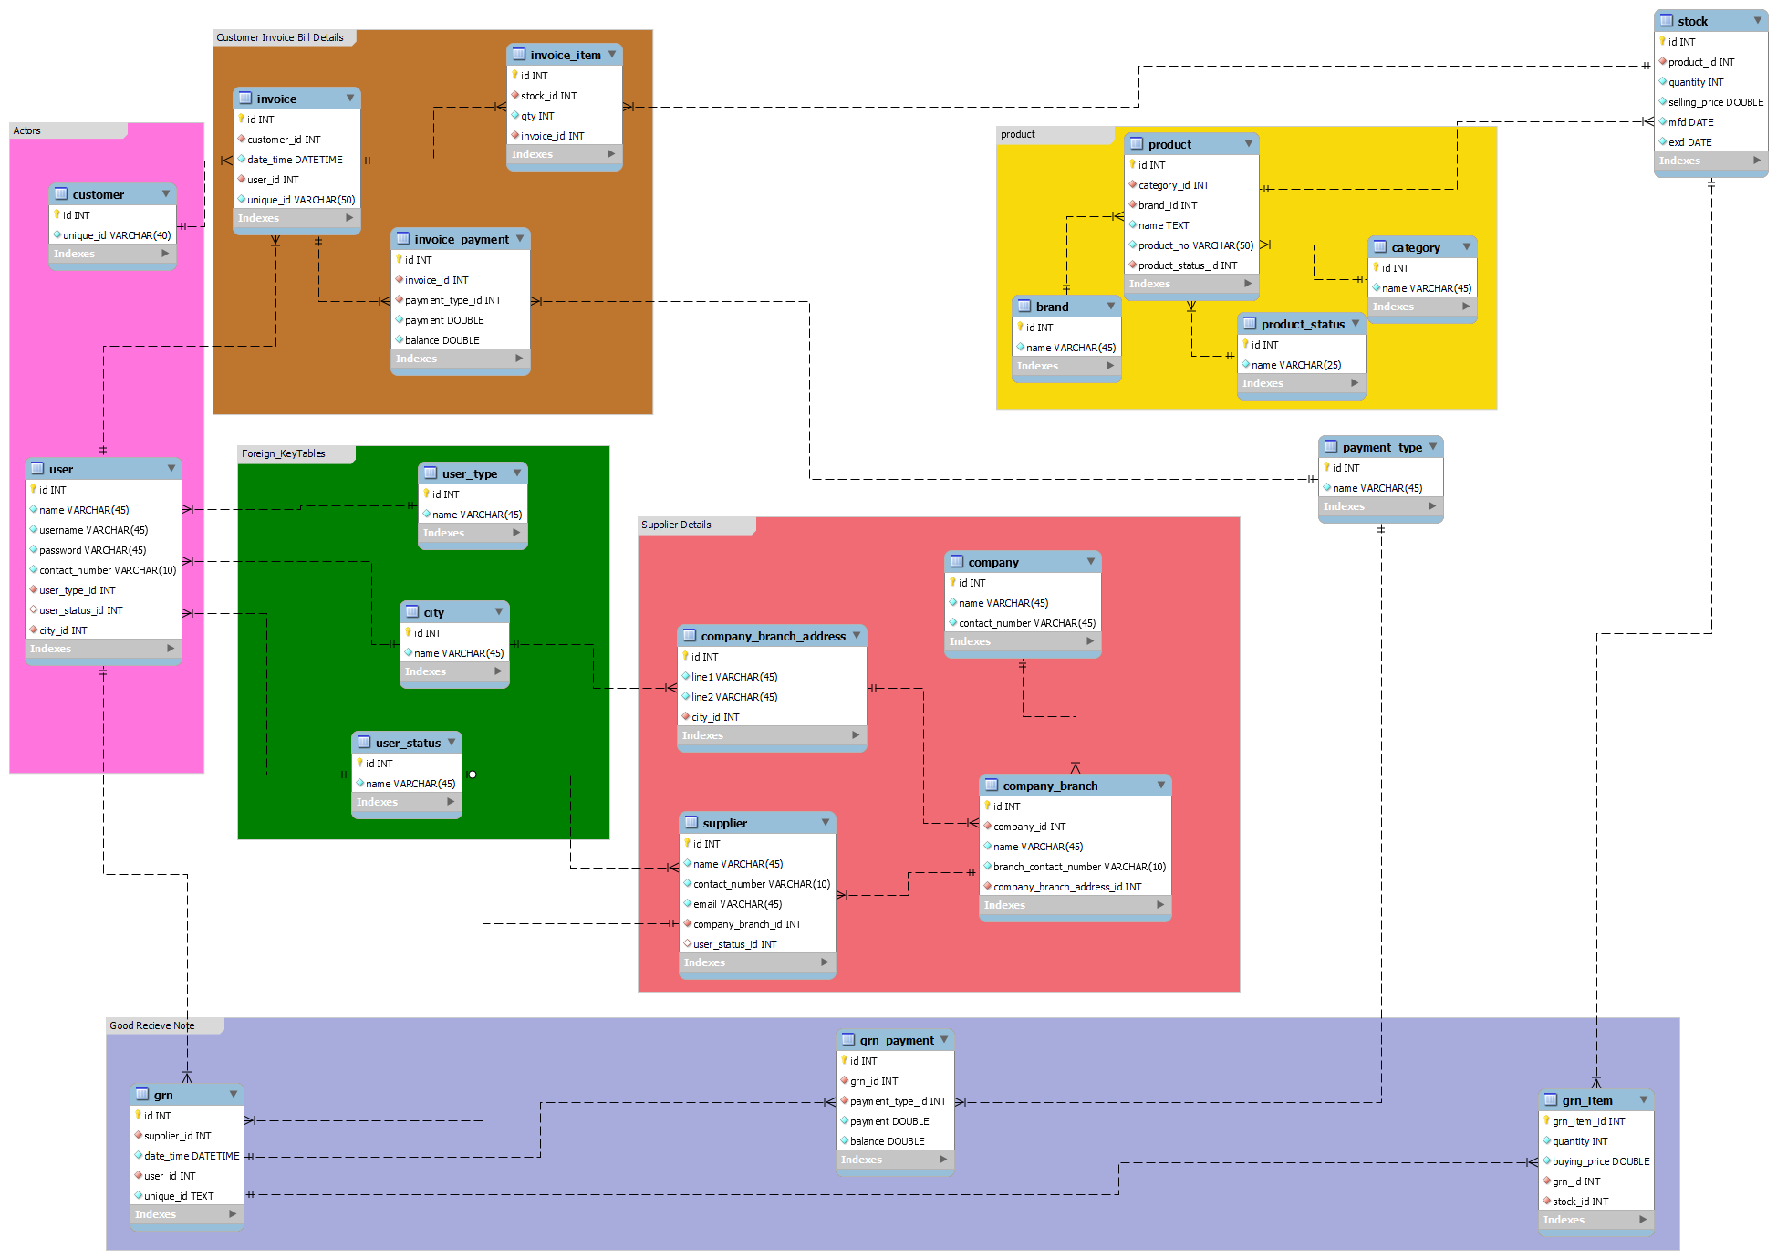

**3.** **Interface Design**

The interface design process is a very important phase of the project. Because the user interacts with the system using the interface. If the interface is not good, the user will not like to work with it. Poor user interface design risks system failure. Good interface design is the reason for the success of the project. User interface design involves using eye-friendly colors, icons and keeping the design simple. The interface is complex and difficult for users to learn.

Show the user who is currently in the system to the user in the user interface. Give the user different ways of doing the same thing.

**UI design guidelines**

* **User friendly**

Design the user interface in a very user friendly manner. User-selectable components, order, colors, text and headings with sizes to keep them highly user-friendly..

* **Easy to learn**

Reduce user interface complexity. Using the interface, the user can easily identify what data is entering the system, what can be done.

* **One click done all**

A user doesn't need to go through more interfaces to complete the task. Most user interfaces allow users to perform their tasks using one interface.

* **Wizard UI**

If the tasks are more complex, it will be divided into several interfaces. The system provides a wizard-to-one interface for users to complete their work simply.

* **Validate UI**

Save only the correct data to the system performed validations. Display error, consistency, and functional status messages to the user for higher data creativity and user understanding.

* **Responsive UI**

Keep the responsive user interface design for working on different screen sizes in this system.

**3.1.1** **Staring Splash**

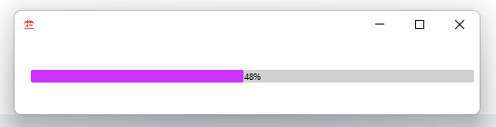

*The splash page represent in Figure 3.5.*

**3.1.2** **System Login**

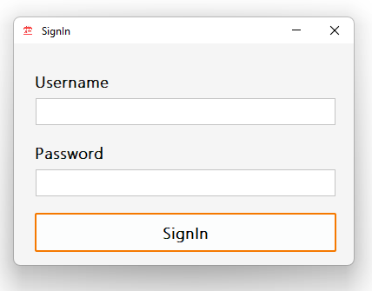

The system user must login with providing correct username and password. If user name and password are mismatch the system will detect its invalid. The system login page represent in Figure 3.6

*The login interface represent in Figure 3.6*

**3.1.3** **Messages**

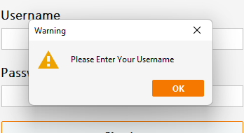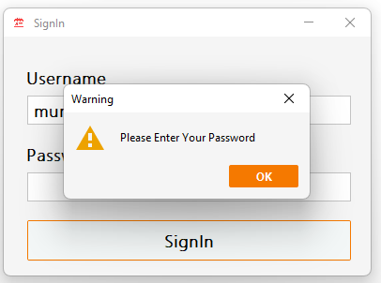

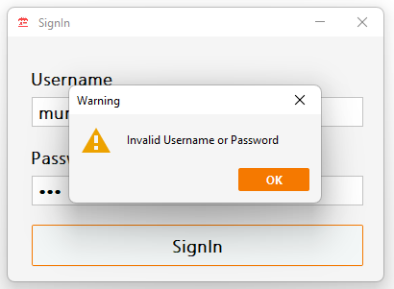

**3.1.4** **GUI’s**

**Home Page**

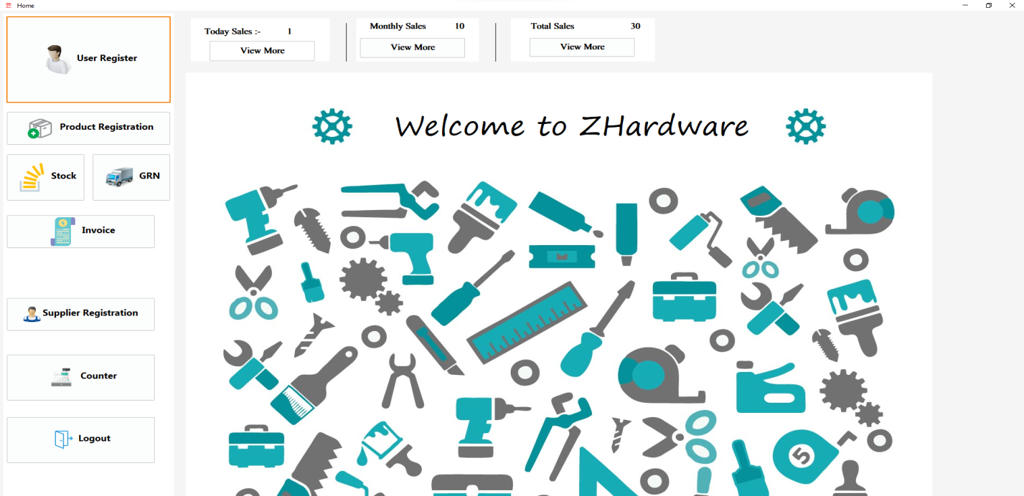

**User Registration**

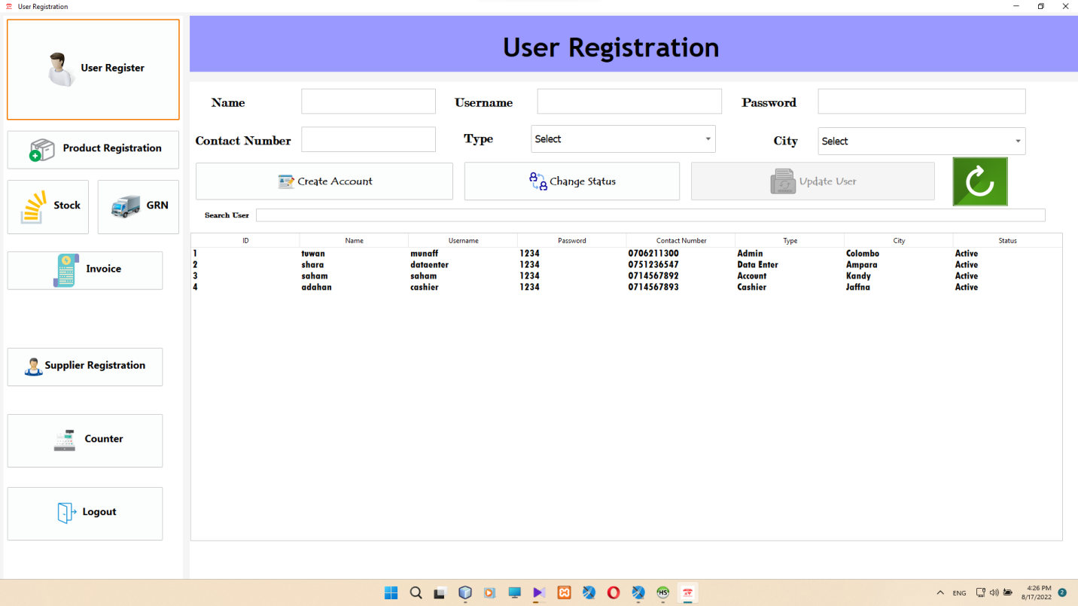

**Product Registration**

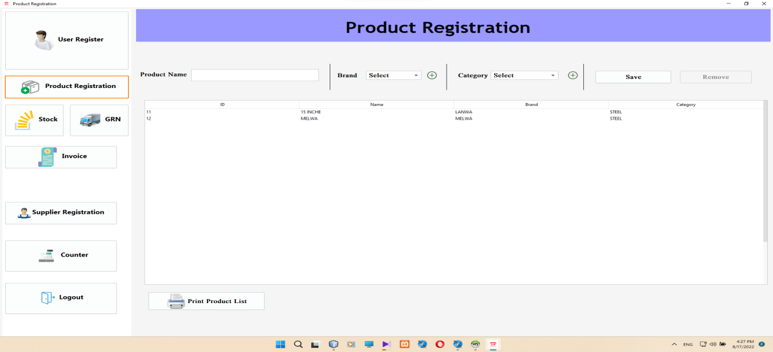

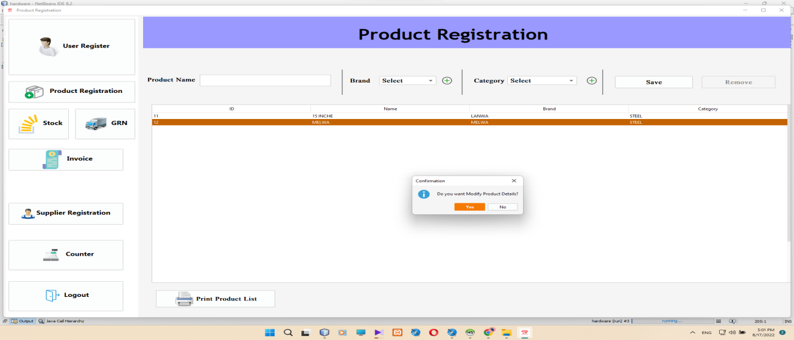

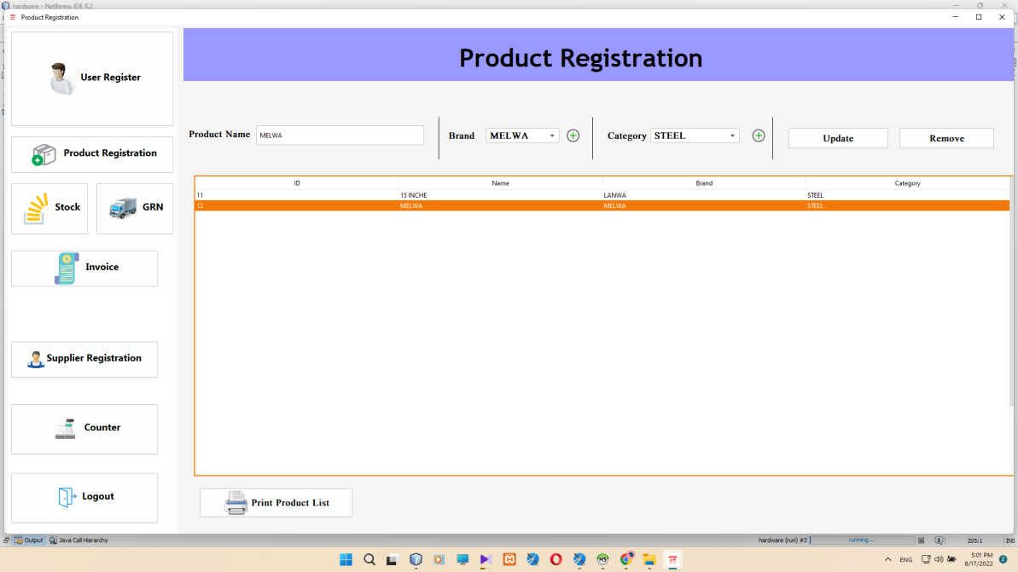

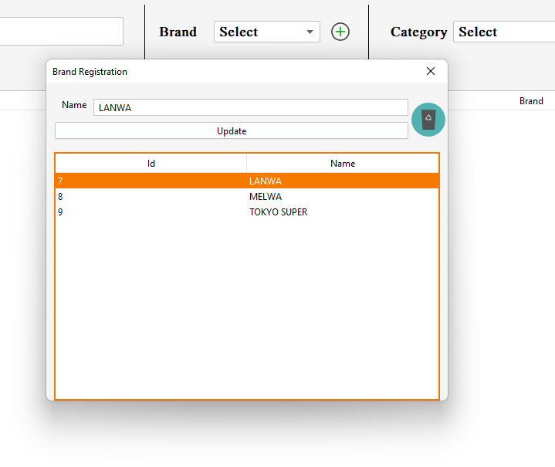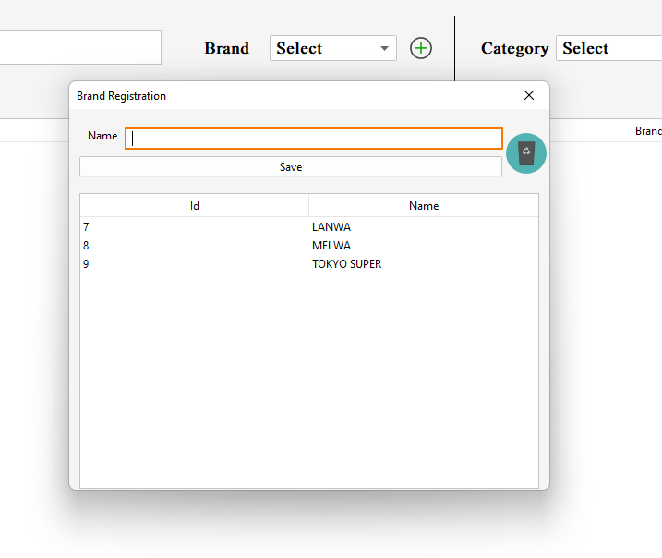

**Brand Registration**

**Category Registration**

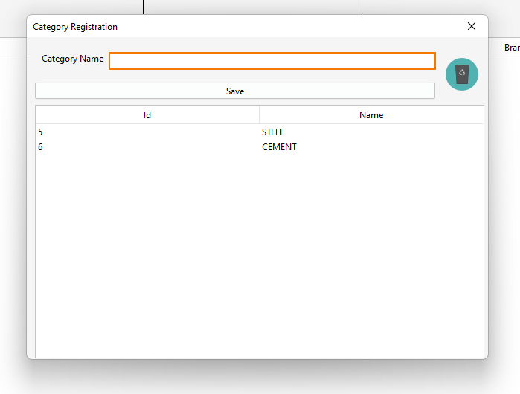

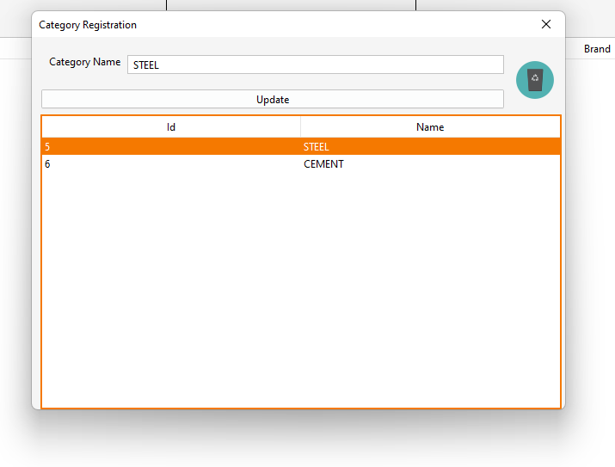

**Manage Stock**

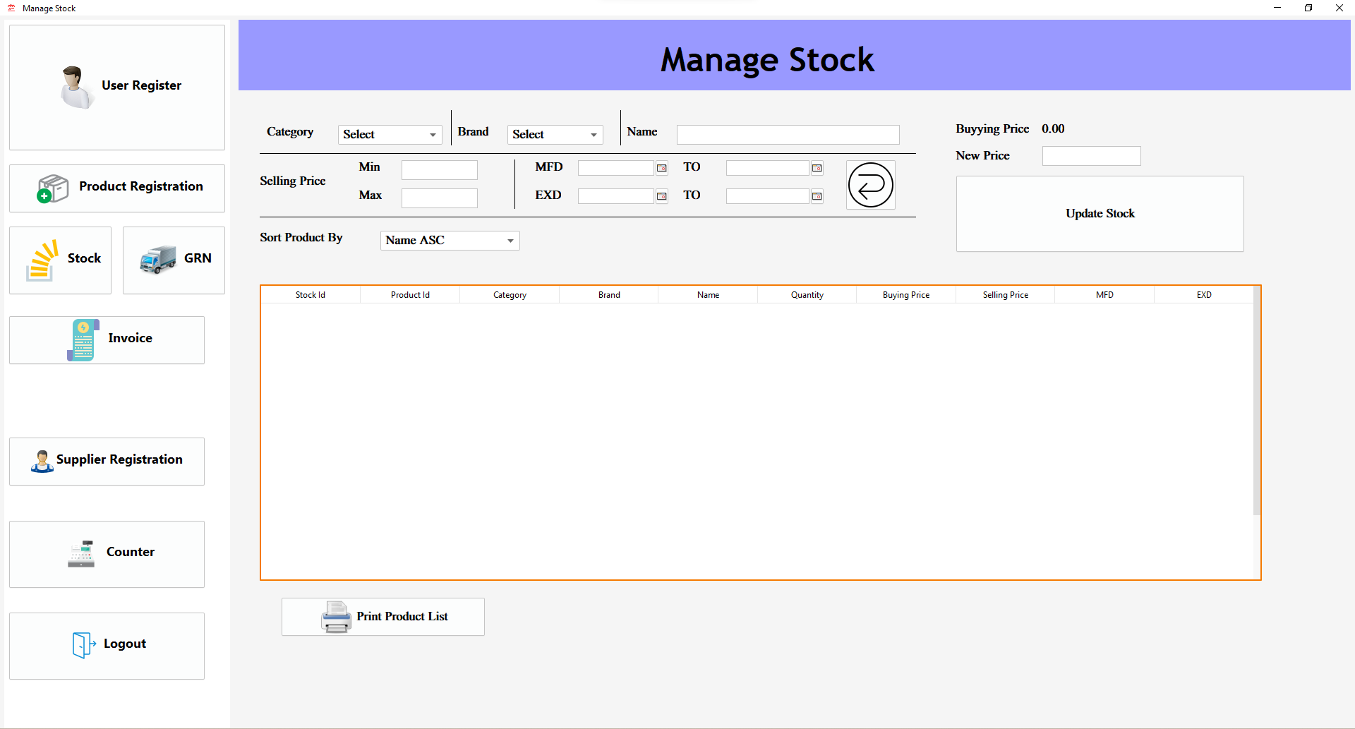

**Good Receive Note**

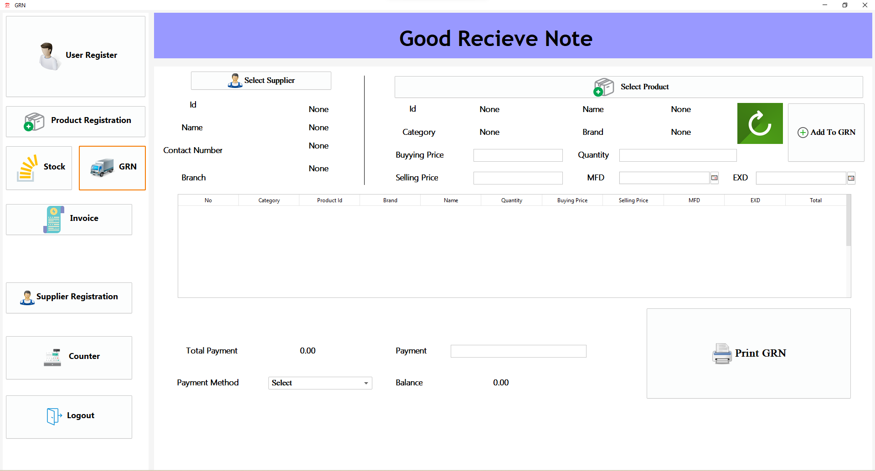

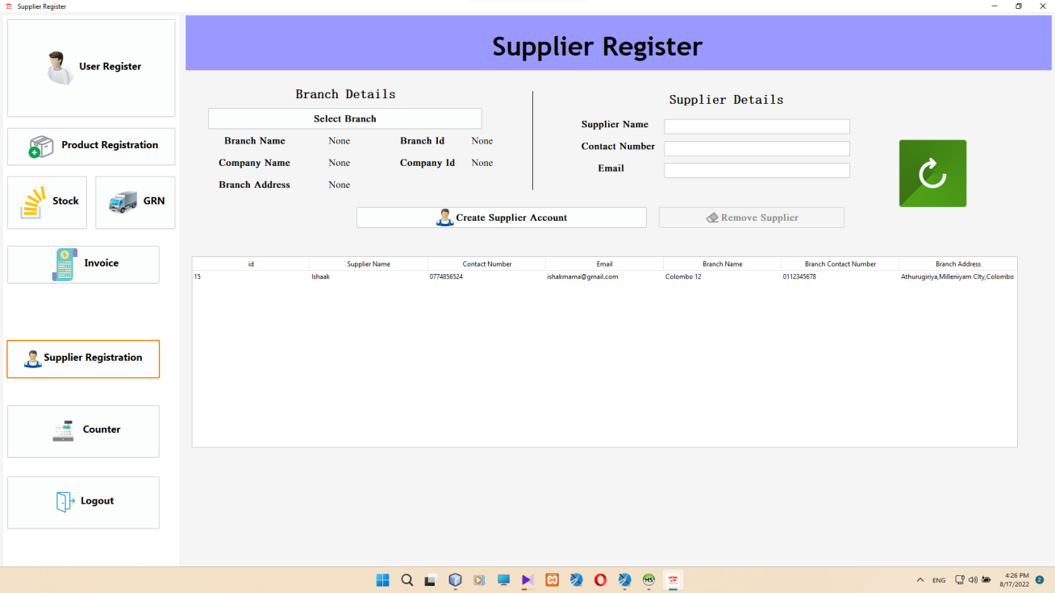

Supplier Registration

Branch Register

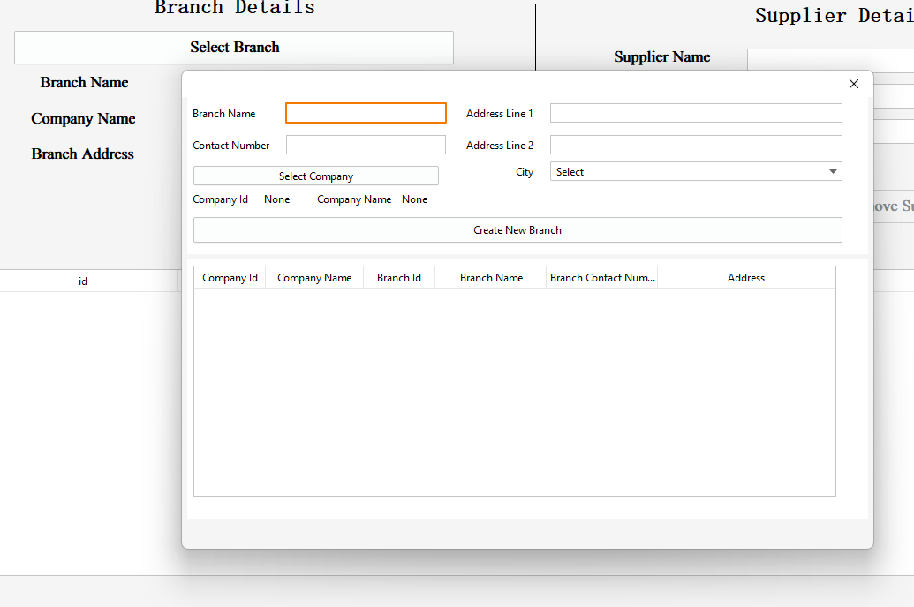

Company Register

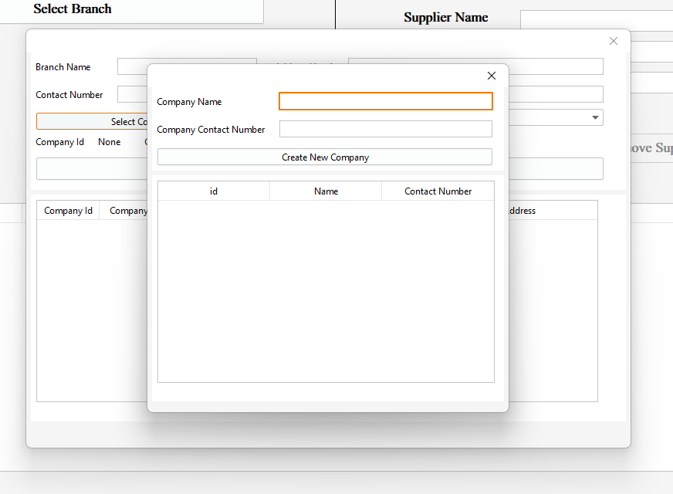

Counter

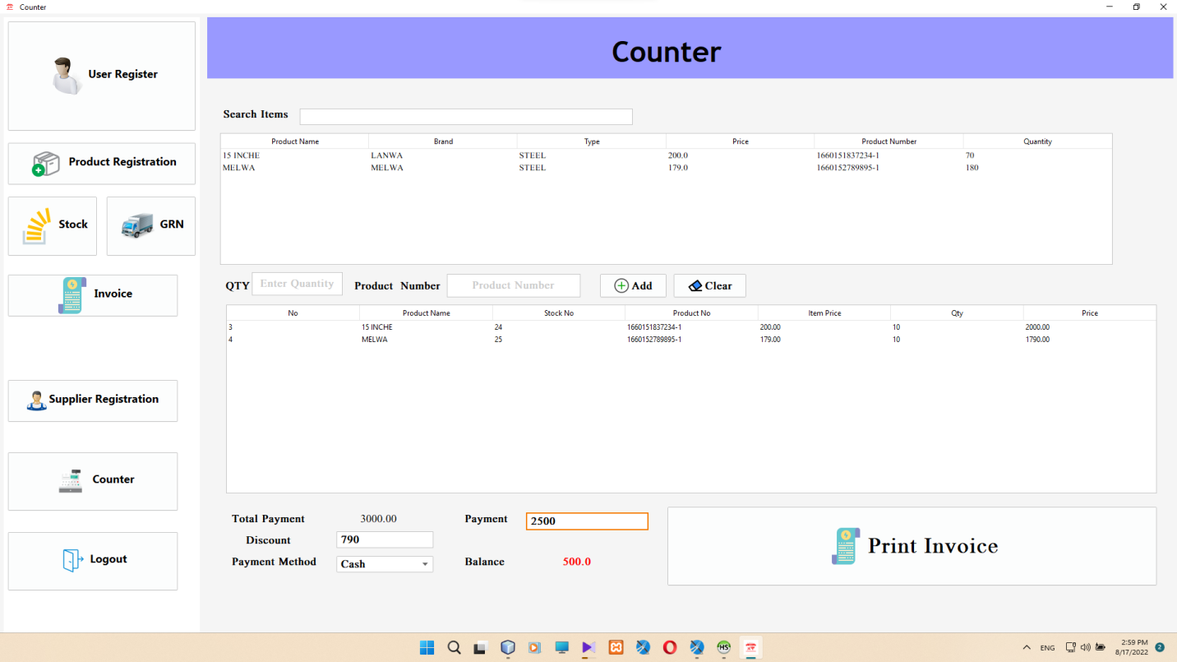

**3.1.5** **Reports**

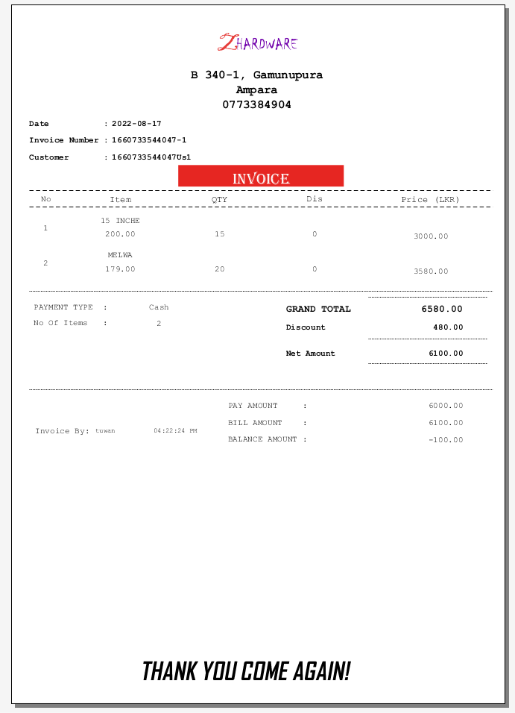

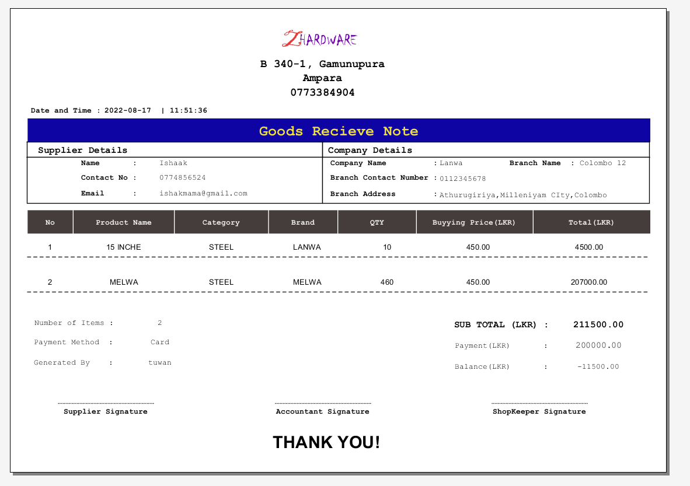

**4. IMPLEMENTATION**

4.1Introduction

The main objective is to convert this phase planning project into a functional system and implement it in the client organization for practical use. This phase requires the least time in the software development life cycle. During this phase, the code project is converted into web applications.

The process of writing code involves the use of ideas and regions. Codification of best practices is very important. Comments are very useful for developer to understand coding without spending time. Regions are used to collapse a large number of line code areas in the Code window.

4.2System Requirements

The system requirements identify three different ways as hardware, software and live ware.

4.2.1 Hardware Requirements

* Computer with HDD 500GB, RAM 2GB, Processor Pentium 4 above.
* Printer

4.2.2 Software Requirements

* OS Microsoft Windows 7 64bit later one.
* MYSQL Server

4.3Development Tools

* **Apache Net Beans**

Apache Net Beans provides editors, wizards, and templates to help you create applications in Java, PHP and many other languages. Apache Net Beans can be installed on all operating systems that support Java, i.e., Windows, Linux, Mac OSX and BSD. Write Once, Run Anywhere, applies to Net Beans too.

* **MYSQL WORKBENCH**

MySQL Workbench is a unified visual tool for database architects, developers, and DBAs. MySQL Workbench provides data modeling, SQL development, and comprehensive administration tools for server configuration, user administration, backup, and much more. MySQL Workbench is available on Windows, Linux and Mac OS X.

* **HeidiSQL**

HeidiSQL is an all-in-one tool for database management, development, and administration. You may use HeidiSQL to remotely connect to a database created here on Hostinger. While our web hosting plans offer phpMyadmin to help with database management, HeidiSQL is the preferred choice for many developers.

* **Jaspersoft® Studio**

Jaspersoft Studio allows you to create sophisticated layouts containing charts, images, sub reports, crosstabs and much more.

4.4Platform (Microsoft)

Microsoft Visual Studio is an integrated development environment (IDE) from Microsoft. It is used to develop computer programs, as well as websites, web apps, web services and mobile apps. Visual Studio uses Microsoft software development platforms such as Windows API, Windows Forms, Windows presentation Foundation, Windows Store and Microsoft Silverlight. It can produce both native code and managed code.

4.5Language (JAVA)

Developers use Java to construct applications in laptops, data centers, game consoles, scientific supercomputers, cell phones, and other devices. Java is the world's third most popular programming language, after Python and C – according to the TIOBE index, which evaluates programming language popularity.

4.6 Code Segments

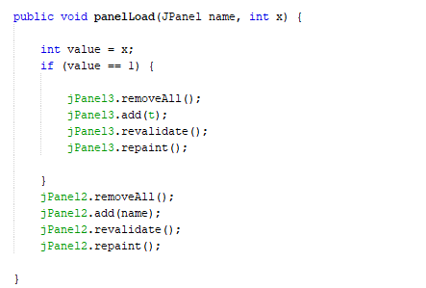4.6.1Panel Load

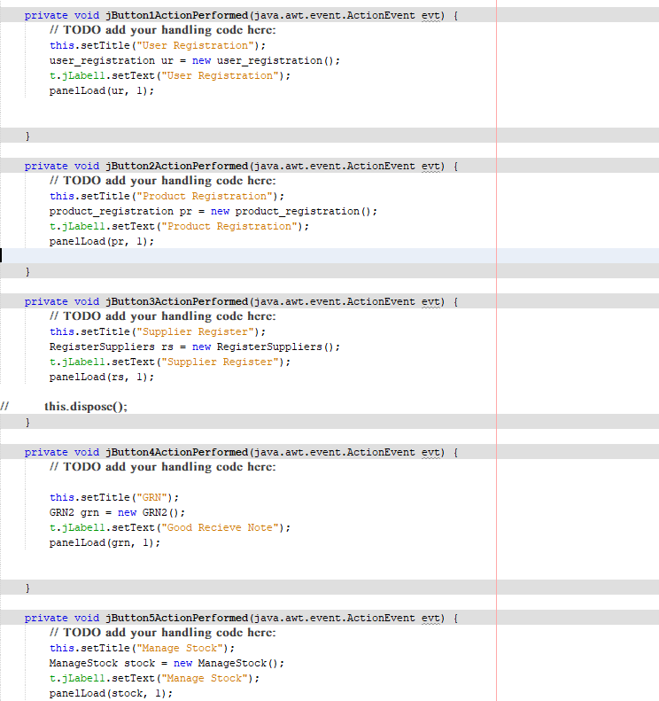

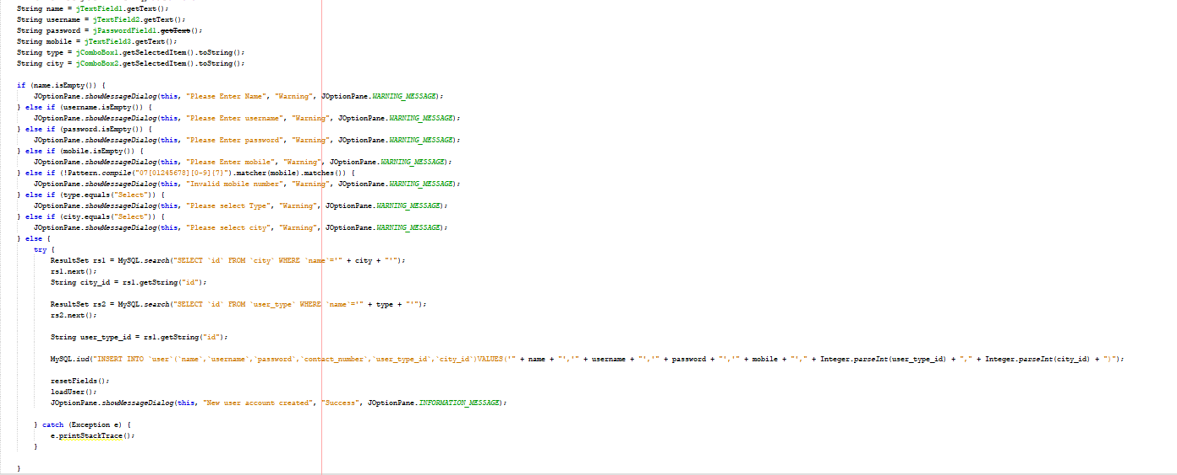4.6.2Register New User

4.6.3User search

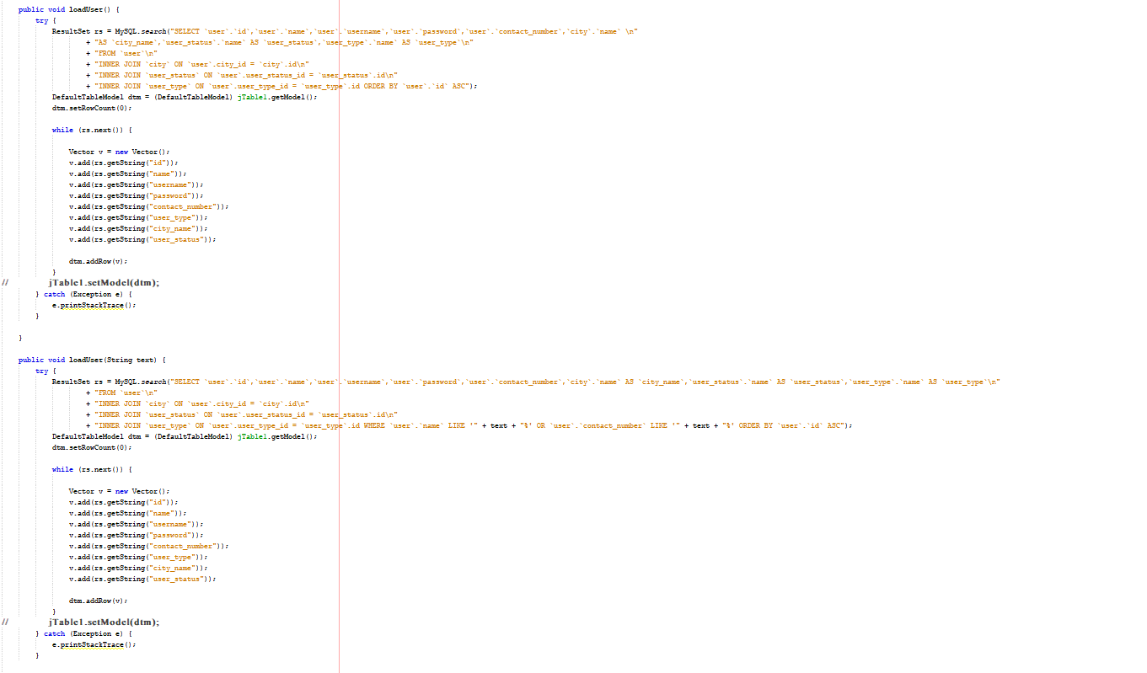

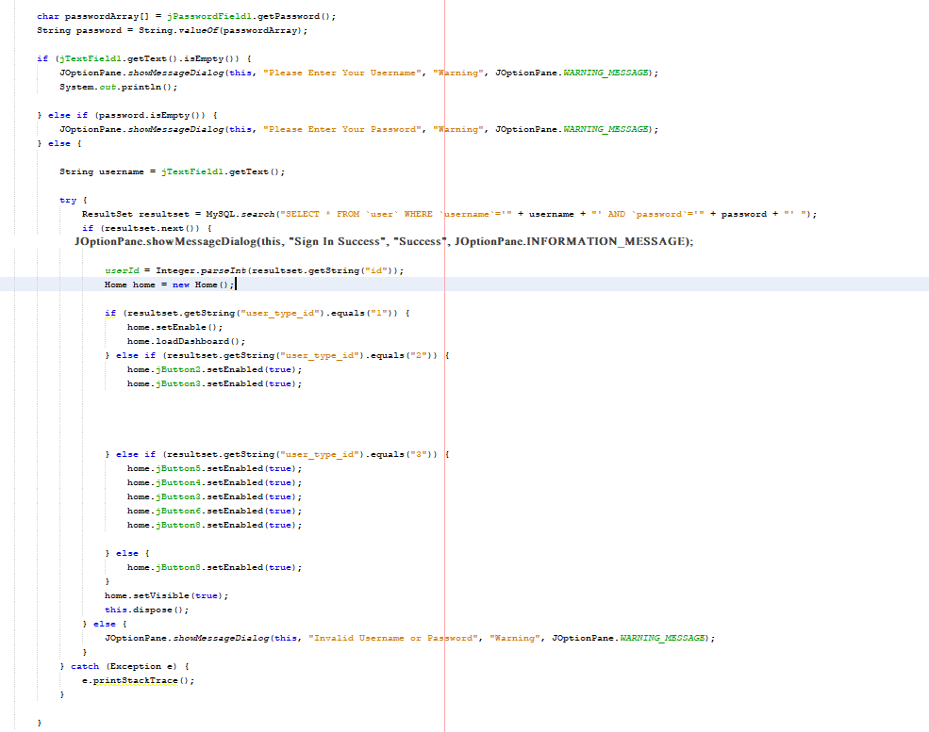4.6.4Sign in Code

4.6.5Load Product in Code

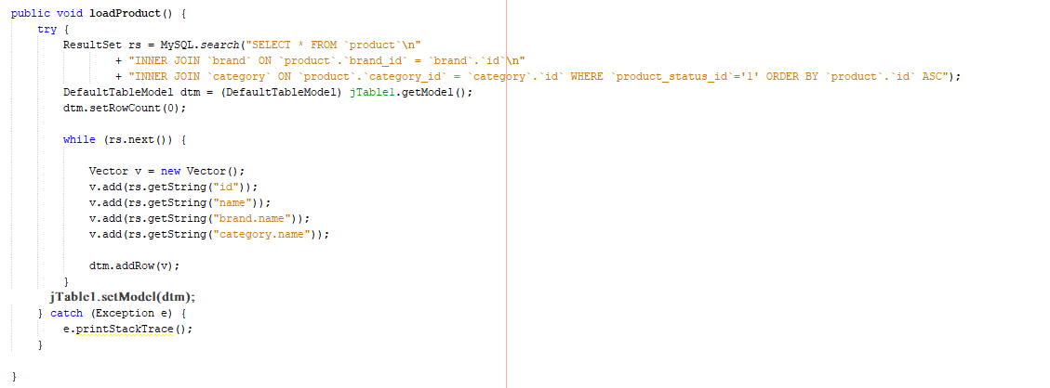

4.6.6Load Brand and Category in Code

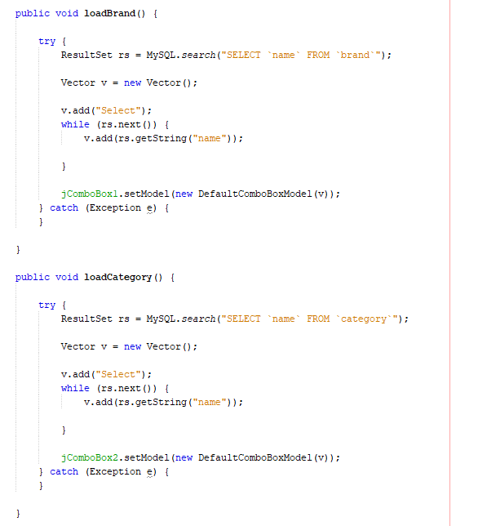

4.6.7Product Insert and Update in Code

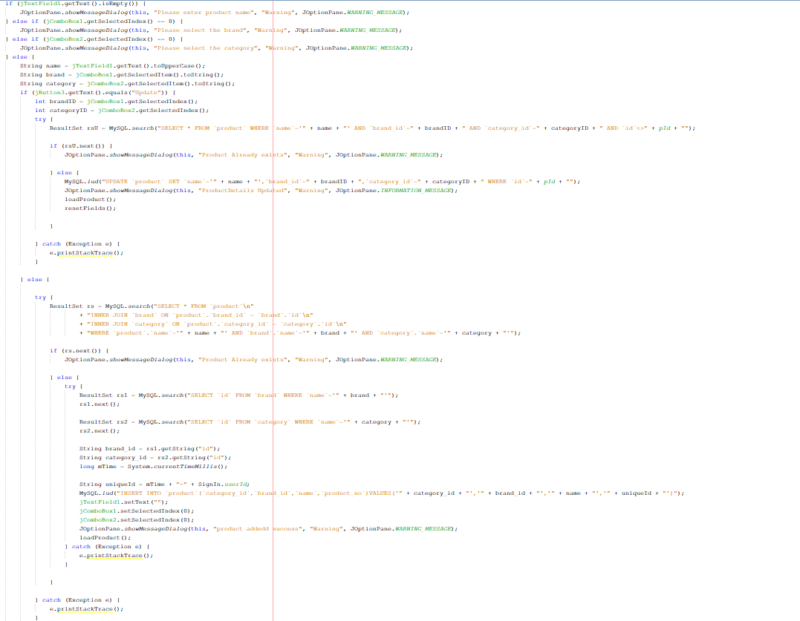

**Conclusion**

I have developed the POS system offline as per my client requirements and it is too backward compared to the new age of technology? I will make this offline system an online base for future upgrade. Currently users need to enter every detail manually. This system has some benefits for their staff. Currently, they are keeping every report by hand in memos. At least this method will give them relief from the tedious life of dealing with their customers. Additionally, this system will make their customers more reliable as all customer records will be kept more secure than before. Moreover, they can manage their shares more easily.

**Reference**

<https://www.techopedia.com/>

<https://www.wikipedia.org/>